**User Diagrams**

Main System page

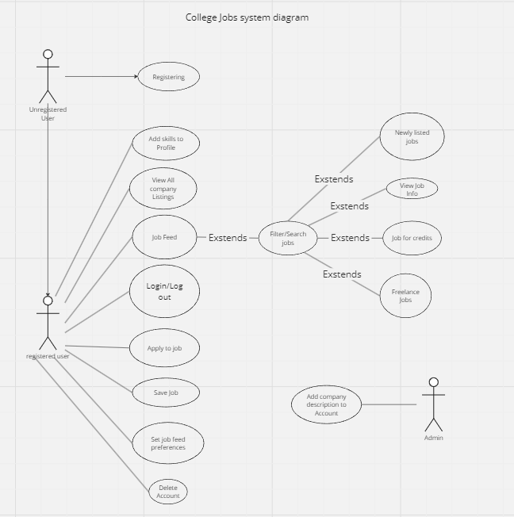

Extending Resources 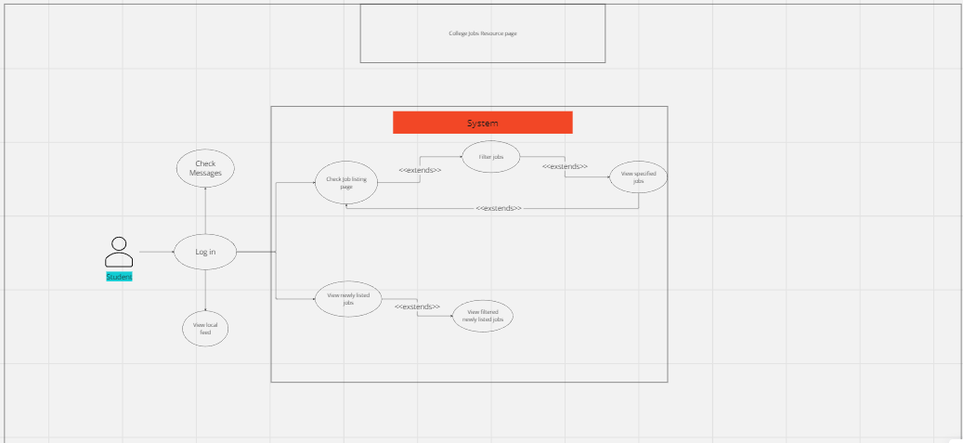

**Use Case Descriptions**

| **Name:** | Save Job | | |
| --- | --- | --- | --- |
| **ID:** | 10 | | |
| **Description** | As a college student, I would like to be able to save a job for later if I find one that I like but want to continue to look for other jobs so I can easily go back and find it later. | | |
| **Precondition:** | * User is viewing a job listing | | |
| **Success Postconditions:** | * The job listing is saved to bookmarks for viewing later. * The user is returned to the feed view. | | |
| **USER STEPS:**  1. Clicks on a relevant job listing  3. Click the “Save” or “Bookmark” button  5. User sees a confirmation message. | | **SYSTEM RESPONSE:**  0. Show a list of jobs  2. Shows information about the job listing, and displays a “Save” or “Bookmark” button  4. Displays a notification indicating it has been saved | |

| **Name:** | Add Company Description to Account |
| --- | --- |
| **ID:** | 11 |
| **Description**: | The company users shall be able to add a company description for the student users to view. |
| **Success Postcondition**: | A company description is added. |

| **USER STEPS**:  1. Company users click the “Create Company Description” button.  3. Types in company description.  4. Click the “Submit” button.  6. Clicks confirm. | **SYSTEM RESPONSE**:  2. Pop up to enter the company description.  4. Verifies input is valid.  5. Displays confirmation.  7. Adds a description to the company profile. |
| --- | --- |

| **Name/Title:** | Apply for Job |
| --- | --- |
| **ID:** | 15 |
| **Description**: | As a student who is looking for a job, I want to be able to apply for the job that I am looking for. |
| **Precondition**: | The user has a website open |
| **Success Postcondition**: | The website brings the application for the job that you are applying to. |

| **USER STEPS**:  1. Users enter the job that they are looking for.  3. Extended- clicks on desired job  5. Click on the link to the application. | **SYSTEM RESPONSE**:  2. Shows a list of all the jobs that fit the search description.  4. The screen displays information about the job and the link to the application.  6. Display the page to fill out the job application. |
| --- | --- |

| **Name/Title:** | View All Company Listings |
| --- | --- |
| **ID:** | 114 |
| **Description**: | As a Student, I want to be able to click on a specific company and be able to see all of the jobs that they have posted and also see a description of what the company does. |
| **System Under Design:** | College Jobs |
| **Primary Actor**: | System |
| **Participants**: | Registered User |
| **Goal**: | See all of a company’s listings. |
| **Related Use Cases**: | Add company description, view job info |
| **Invariant**: | The user needs to be logged out |
| **Precondition**: | The user must be logged in |
| **Success Postcondition**: | Pops up all of a company’s listings. |

| **USER STEPS**:  1. The user opens search menu  3. Users click a company.  5. User picks all company listings. | **SYSTEM RESPONSE**:  2. System shows search menu  4. The system shows the company page  6. System returns all of the company’s listings. |
| --- | --- |

| **Name:** | Filter jobs |
| --- | --- |
| **ID:** | 14 |
| **Description**: | As a user, I want to be able to use a filter to search for jobs that are more suitable for me and match the requirements that I am looking for. |
| **Primary Actor**: | User |
| **Participants**: | System |
| **Goal**: | Filter the jobs to the users choosing |
| **Related Use Cases**: | Set preferences |
| **Invariant**: | User must be using the search bar |
| **Precondition:** | The user is viewing the job feed or job search page |
| **Success Postcondition**: | The app shows only jobs that match the filter conditions |

| **USER STEPS**:  1. Click on the “Filter” button to the left of the job list  3. Select one or more filter conditions  4. Clicks “Submit” | **SYSTEM RESPONSE**:  2. Shows filter sidebar with sliders for min/max pay and date posted, and drop downs for job category, location radius, and skills required  4. Clicked filter conditions are highlighted  5. System checks each job listing against filters   1. Shows only jobs that match the filter conditions or 2. Displays “No jobs match filters” |
| --- | --- |

| **Name/Title:** | Registering |
| --- | --- |
| **ID:** | 101 |
| **Description**: | As a Student or Company, I want to be able to register for a new account using an email. |
| **System Under Design:** | College Jobs |
| **Primary Actor**: | Unregistered User |
| **Participants**: | students |
| **Goal**: | To be able to register to use the site |
| **Related Use Cases**: | Log in, sign up |
| **Invariant**: | The user must be registered |
| **Precondition**: | The user can not have an account |
| **Success Postcondition**: | Registers the user brings them to the profile page |

| **USER STEPS**:  1. User clicks register  3. Fill out the information and click submit  … | **SYSTEM RESPONSE**:  2. System brings them to sign up page  4. System brings them to their profile  … |
| --- | --- |

| **Name/Title:** | Job Feed |
| --- | --- |
| **ID:** | 107 |
| **Description**: | As a student, I want to be able to see a feed of jobs on the home screen that the site is recommending to me so that I might be able to find jobs that I might not have thought to search for. |
| **System Under Design:** | College Jobs |
| **Primary Actor**: | Registered User |
| **Participants**: | Unregistered users, employers |
| **Goal**: | To have an active feed of current job offers. |
| **Invariant**: | The user must be logged in |
| **Precondition**: | The user must click on the job feed |
| **Success Postcondition**: | Brings the user to the active job feed. |

| **USER STEPS**:  1. The user clicks on the job feed.  … | **SYSTEM RESPONSE**:  2. The system pops up the job feed  … |
| --- | --- |

| **Name/Title:** | Freelance Jobs |
| --- | --- |
| **ID:** | 112 |
| **Description**: | As a college student, I want to be able to find a freelance job on the website so that I can still work even if I do not have the time for a full-time or part-time job. |
| **System Under Design:** | College Jobs |
| **Primary Actor**: | Registered User |
| **Participants**: | Employers |
| **Goal**: | The option to apply for freelance work. |
| **Related Use Cases**: | Filter Jobs, set job preferences |
| **Invariant**: | The user must work full time |
| **Precondition**: | Freelance job offerings |
| **Success Postcondition**: | Can apply to do freelance work |

| **USER STEPS**:  1. User goes to search bar  3. User searches “Freelance”  4.2. The user sees list of freelance jobs  … | **SYSTEM RESPONSE**:  2. System search bar indicated  4. The system filters for freelance jobs  … |
| --- | --- |

| **Name/Title:** | Job for Credits |
| --- | --- |
| **ID:** | 115 |
| **Description**: | As a college student, I want to be able to find a job that could qualify me to get college credits toward my degree. |
| **System Under Design:** | College Jobs |
| **Primary Actor**: | Registered User |
| **Participants**: | colleges |
| **Goal**: | The student can work and get college credit at the same time. |
| **Related Use Cases**: | Job listings, job filtering |
| **Invariant**: | User must be logged out |
| **Precondition**: | Must be a registered user in college |
| **Success Postcondition**: | Can apply for jobs that will give a college credit |

| **USER STEPS**:  1. User filters searches using filter button and selecting through the options  … | **SYSTEM RESPONSE**:  2. System filters for the specified jobs  2.2 shows the list of options  … |
| --- | --- |

| **Name/Title:** | View Job |
| --- | --- |
| **ID:** | 16 |
| **Description**: | As a student I would like to view a job and its details  When a job is clicked you will see the title of the job, description, company, and link to apply if they have one. |
| **System Under Design:** | College Jobs |
| **Primary Actor**: | Student |
| **Participants**: | Students |
| **Goal**: | To be able to receive updated listings from employers. |
| **Related Use Cases**: | Filter job, search for job |
| **Invariant**: | User must be logged out |
| **Precondition**: | Must be a registered user. |
| **Success Postcondition**: | Able to view a job and description information |

| **USER STEPS**:  1. User clicks on the job they want to view  … | **SYSTEM RESPONSE**:  2. System pops up the job and description information  … |
| --- | --- |

| **Name/Title:** | Set job feed preferences. |
| --- | --- |
| **ID:** | 117 |
| **Description**: | As a student I would like to set job preferences so the system will give me better suggestions. |
| **System Under Design:** | College Jobs |
| **Primary Actor**: | Student |
| **Participants**: | Student |
| **Goal**: | To receive job listings based on job preferences. |
| **Related Use Cases**: | Job feed |
| **Invariant**: | User must be logged out |
| **Precondition**: | Must be a registered user. |
| **Success Postcondition**: | Job listings on job feed will tailor towards job preferences. |

| **USER STEPS**:  1. User clicks on set job preferences.  3. User selects which options to set for job preferences.  … | **SYSTEM RESPONSE**:  2. System returns options for the user to select. E.x full time, part time, freelance, remote, on-site, etc  4. System sets selected job preferences for the user.  5. System displays job listings on job feed for users based on the preferences.  … |
| --- | --- |

| **Name/Title:** | Add Skills to Profile |
| --- | --- |
| **ID:** | 119 |
| **Description**: | As a student I would like to be able to add skills to my profile so when I apply it will auto fill into the application. |
| **System Under Design:** | College Jobs |
| **Primary Actor**: | Student |
| **Participants**: | Student |
| **Goal**: | To add skills to a user’s profile so they auto fill when a user uses “easy apply.” |
| **Related Use Cases**: | Apply for a job. |
| **Invariant**: | User must be logged out |
| **Precondition**: | Must be a registered user. |
| **Success Postcondition**: | Skills added to user profile |

| **USER STEPS**:  1. User clicks on set skills.  3. User enter’s skills they wish to have listed on their profile.  … | **SYSTEM RESPONSE**:  2. System pops up an input box where users can enter their skills..  4. System sets skills for the user.  5. System autofills skills into an application when the user uses “easy apply.”  … |
| --- | --- |